**OBJECT ORIENTED PROGRAMMING**

**LAB# 11**

## **Graphical User Interface(GUI) in Java**

Exercise:

Write a program that takes Student name and its course name as input and displays the result in toString Format in the list.You should be able to add, update and delete the student item from the Jfram form using the add, update and delete buttons.  
You should first create a student class and then call its methods in your Gui class.

**Form Design:**

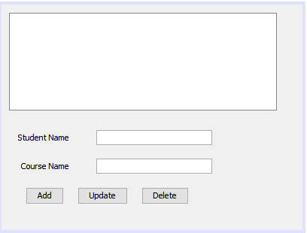

**Student.java**

package my.Gui;

public class Student {

private String StudentName

private String CourseName;

public String ToString()

{

return "Student={Name=" + StudentName + ",Course=" + CourseName + "}";

}

public void setName(String Name)

{

StudentName = Name;

}

public String getName()

{

return StudentName;

}

public void setCourseName(String course)

{

CourseName= course;

}

public String GetCourseName(){

return CourseName;

}

}

TaskGUI.java

package my.Gui;

import java.util.ArrayList;

import javax.swing.DefaultListModel;

import javax.swing.JOptionPane;

public class TaskGUI extends javax.swing.JFrame {

static ArrayList<Student> Students;

int index;

public TaskGUI() {

initComponents();

Students=new ArrayList<Student>();

Populate();

LoadStudentsInList();

}

public void Populate()

{

Student s=new Student();

s.setName("Saniya");

s.setCourseName("OOP");

Students.add(s);

}

private void AddbtnMouseClicked(java.awt.event.MouseEvent evt) {

Student temp=new Student();

temp.setName(NameTxt.getText());

temp.setCourseName(CourseTxt.getText());

Students.add(temp);

LoadStudentsInList();

}

private void UpdateBtnMouseClicked(java.awt.event.MouseEvent evt) {

index=StdList.getSelectedIndex();

if(index<0)

{

JOptionPane.showMessageDialog(this,"Please select Student First");

return;

}

Students.remove(index);

Student temp=new Student();

temp.setName(NameTxt.getText().toString());

temp.setCourseName(CourseTxt.getText().toString());

Students.add(temp);

LoadStudentsInList();

}

private void DelbtnMouseClicked(java.awt.event.MouseEvent evt) {

index=StdList.getSelectedIndex();

if(index<0)

{

JOptionPane.showMessageDialog(this,"Please select Student First");

return;

}

if(index>=0)

{

Students.remove(index);

}

LoadStudentsInList();

}

public void LoadStudentsInList()

{

DefaultListModel<String> model=new DefaultListModel<String>();

for(Student std: Students)

{

model.addElement(std.ToString());

}

StdList.setModel(model);

}

/**

* @param args the command line arguments

*/

public static void main(String args[]) {

/* Create and display the form */

java.awt.EventQueue.invokeLater(new Runnable() {

public void run() {

new TaskGUI().setVisible(true);

}

});

}

}